|  |  |  |
| --- | --- | --- |
| **Lyng Primary School P.E Knowledge Organiser** | | |
| **Topic: Football** | Year 2 | Autumn 2 |

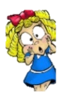



**Enquiry Questions**

* How should we stop/control the ball?
* Can we keep control of the ball, when dribbling at speed?
* Can we pass with accuracy using our weaker foot?
* Can we choose the right technique when shooting from different positions on the pitch?
* How can we attack the defending team?
* Can we transfer skills into a game situation?

|  |  |
| --- | --- |
| **Key words** | |
| **Spelling** | **Definition** |
| Pass | When transferring the ball to one team mate by kicking the ball. |
| Dribble | When players dribble the ball in football, they are travelling with the ball showing close control. |
| Score | In a game of football, if a player scores a goal they gain a goal/point for their team. |
| Penalty | When a foul is given in the penalty area a penalty (free shot) is awarded. |
| Shoot | Shooting the ball at the goal, when trying to score for the team. |
| Save | When the goalkeeper prevents the ball from going into their goal. |

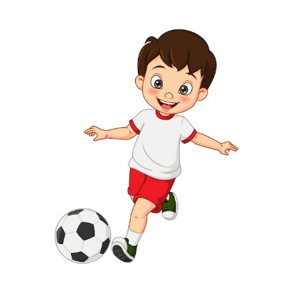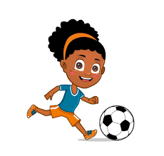

***“Football has to be fun for kids or it doesn’t make sense”***

**– Johan Cruyff**

**– Mav Levy**

|  |  |  |
| --- | --- | --- |
| **Lyng Primary School P.E Knowledge Organiser** | | |
| **Topic: Football** | Year 2 | Autumn 2 |

Learning Outcomes

* To develop control the ball when you stop
* To keep close control of the ball when dribbling
* To be able to consistently hit a target when passing an aiming at a target.
* To score as many goals when shooting.
* To gain an understanding on attacking.
* To gain a basic understanding of the rules of football.

